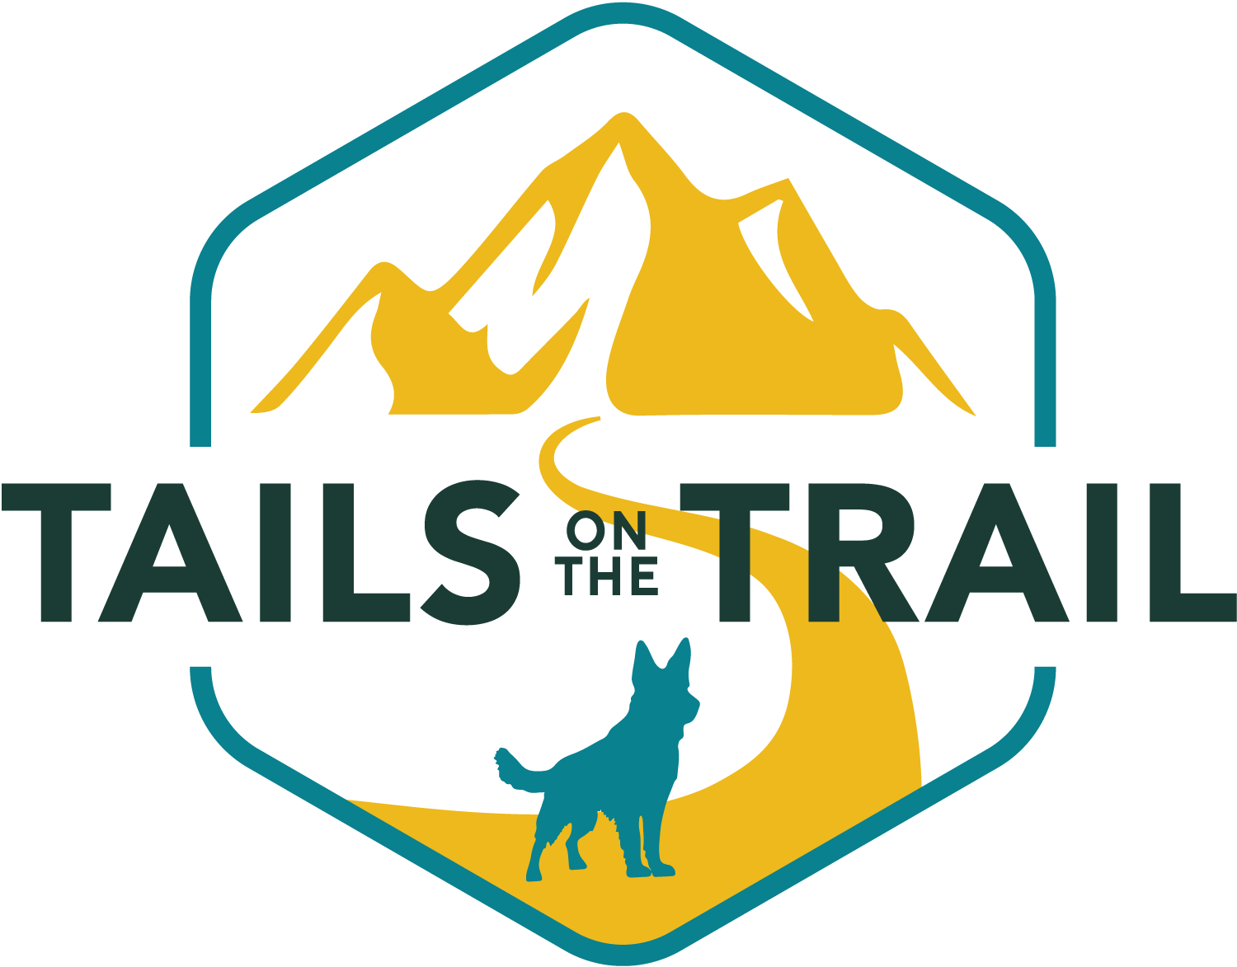

**Terms and Conditions**

1. I agree to provide/arrange for keys to be available for Tails on the Trail ahead of a dog walking appointment.
2. I authorise Tails on the Trail to obtain any emergency veterinary care that may be necessary during the time spent with my dog(s). I understand that every effort will be made to contact me prior to obtaining emergency care. I accept responsibility for any charges related to this emergency care. I also authorise Tails on the Trail to use an alternative veterinarian if my regular veterinarian is unavailable.
3. I will be responsible for any medical expenses and damages resulting from an injury to the dog walker or other persons/animals by my dog(s).
4. I realise I must give a minimum of 24 hours’ notice to cancel any walking appointments or the full amount of the service will be collected. Cancellations by the customer are required to be made as soon as possible via telephone/email. I realise payment is non-refundable if a cancellation is made for a walking service without adequate notice
5. I agree to pay Tails on the Trail in full after the service, late payment will result in the service stopping.
6. Tails on the Trail will inform me of any incident or anything they notice about the dog(s) which the owner should know.
7. I understand that Tails on the Trail reserves the right to refuse to walk any dog.
8. I understand my dog must wear a collar and ID Tag whilst out on walks.
9. I understand I must declare if I use apple id tags, trackers, cameras, or monitoring systems in the home for the walker’s personal safety.
10. I understand that my dog(s) is to be fully vaccinated to attend walk sessions.
11. I consent to my dog being photographed, videotaped, and/or used in any media or advertising by Tails on the Trail without prior approval.
12. I agree that Tails on the Trail is not responsible for any lost, stolen, or damaged leads, collars, tags, clothing or any other item left with their dog.
13. I agree to ensure my dog has not eaten in the hour before pick up Tails on the Trail to ensure sufficient time to digest food before any exercise or play.Failure to do so may result in the potentially life-threatening condition Bloat (Gastric Torsion).
14. I declare that my dog(s) is not on the banned breed list in accordance with UK law.
15. I declare that my dog(s) is not under a Dog Control Order and that if this should change, I will inform Tails on the Trail prior to my next arranged service.
16. I declare that any history of human/dog bites will be disclosed to Tails on the Trail during the consultation, and a suitable basket muzzle will be provided if the dog has a bite history.
17. I understand walks may be cancelled during periods of extreme weather.
18. I understand I must leave my dog in an accessible location for collection
19. I understand that Tails on the Trail cannot walk a bitch in season
20. I understand I must declare to Tails on the Trail if myself or a member of my family have an infectious illness, including COVID19, cold, flu, covid, chicken pox, etc, and understand my dog may not be walked during this time with a Tails on the Trail walker.
21. I declare that everything discussed during the consultation I know to be true and a fair representation of my dog(s).

|  |  |
| --- | --- |
| Full Name |  |
| Signed |  | Date |  |

**General Information**

|  |  |
| --- | --- |
| Owners Name |  |
| Address |  |
| Email Address |  |
| Phone Number |  |
| Contact 2 Name and number |  |
| Contact 3 Name and Number |  |
| Vet Name |  |
| Vet Address |  |
| Vet Phone Number |  |

**Access Information**

|  |  |
| --- | --- |
| Will Tails and the Trails need access to your house when you are not home? |  |
| Will provide a key for Tails on the Trail to hold? |  |
| If you leave a key in a secure location, do you understand you are fully responsible its security? |  |

**Dogs Details**

|  |  |
| --- | --- |
| Name |  |
| Breed |  |
| Age |  |
| Male or female |  |
| Is your dog neutered |  |
| Unneutered female date of last season? |  |
| Is your dog microchipped? |  |
| Are your dog’s vaccines up to date? |  |
| Date of last vaccines |  |
| Allergies |  |

Please list any pre-existing health conditions

|  |
| --- |
|  |

Please list any medications your dog is currently taking and instructions

|  |
| --- |
|  |

Please indicate if your dog has any sensitive areas on their body

|  |
| --- |
|  |

Please describe any restrictions on your dog’s activity (e.g. due to physical limitations such as hip dysplasia)

|  |
| --- |
|  |

**Social Skills**

Please give a brief overview of your dogs training so far

|  |
| --- |
|  |

How does your dog react to people and other dogs on walks?

|  |
| --- |
|  |

Is your dog ok with people entering your home?

|  |
| --- |
|  |

**Behaviour**

Please describe general behaviour and energy levels (both inside and when out)

|  |
| --- |
|  |

Please provide details if your dog is anxious around, or frightened by, any of the following:

|  |  |
| --- | --- |
| Noises |  |
| Actions |  |
| Objects |  |
| Breeds/Types of dogs |  |
| Types of people |  |

Where does your dog sit when travelling in the Car? Front? Back? Boot?

|  |
| --- |
|  |

Does your Dog ever get car sick?

|  |
| --- |
|  |

Does your dog behave differently on and off lead?

|  |
| --- |
|  |

Does your dog play off lead with other dogs?

|  |
| --- |
|  |

How does your dog behave around livestock?

|  |
| --- |
|  |

Has your dog ever jumped on someone (if so, please describe the circumstances)?

|  |
| --- |
|  |

Has your dog growled or snarled at someone (if so, please describe the circumstances)?

|  |
| --- |
|  |

Has your dog ever bitten someone (if so, please describe the circumstances)?

|  |
| --- |
|  |

Has your dog ever bitten another dog, other than play-biting (if so, please describe the circumstances)?

|  |
| --- |
|  |

Does your dog allow you to take things out of his/her mouth?

|  |
| --- |
|  |

Please delete as appropriate from the below table

|  |  |  |
| --- | --- | --- |
| **Will Chase:**  Doesn’t chase  Cats  Deer  Livestock  Small Animals  Other: | **Offlead with owner:**  Yes - always  Usually  Occassionally  Never | **Recall:**  Very Good  Average  Poor  Notes: |
| **Type of lead usually used**  short line  long line  flexi  slip lead  Other: | **Types of restraint**  Harness  Flat collar  Martingale collar  Slip collar  Prong/Pinch Collar  Head collar  E-collar  Muzzle  Other: |  |

**Routine**

Please describe pick up and return routine

|  |
| --- |
|  |

Please give any other information that you think would be useful to enable us to give your dog the best possible care while under the care of Tails on the Trail

|  |
| --- |
|  |

**Disclaimer & Waiver of Liability:**

The information I have given in this application is true, correct and complete to the best of my knowledge. I have read and agree to abide by the Terms and Conditions for services received from Tails on the Trail. I hereby indemnify Tails on the Trail and their staff against liability of any kind whatsoever arising from my dog’s participation in any services offered by Tails on the Trail

|  |  |  |  |
| --- | --- | --- | --- |
| Signed |  | Date |  |

**Off the Lead Consent Form:**

I agree to Tails on the Trail having the right to allow my dog off the lead and understand that all terms and conditions remain the same. I have read and agree to abide by the Terms and Conditions for services received from Tails on the Trail. I hereby indemnify Tails on the Trail and their staff against liability of any kind whatsoever arising from my dog’s participation in any services offered by Tails on the Trail.

All dogs will be initially walked on a long line until Tails and the Trail are confident that your dog will reliably recall every single time when called.

|  |  |  |  |
| --- | --- | --- | --- |
| Signed |  | Date |  |

**Key Holder Disclaimer & Waiver of Liability:**

The information I have given in this application is true, correct and complete to the best of my knowledge.I have read and agree to abide by the Terms and Conditions for services received from Tails on the Trail. I understand that this form acts as permission to hold keys to my property, which I have provided willingly. I hereby indemnify Tails on the Trail and their staff against liability of any kind whatsoever arising from damage or loss of any property.

|  |  |  |  |
| --- | --- | --- | --- |
| Signed |  | Date |  |

**Medical Disclaimer:**

I authorise Tails on the Trail to obtain any emergency veterinary care that may be necessary during the time spent with my dog(s). I understand that every effort will be made to contact me prior to obtaining emergency care. I accept responsibility for any charges related to this emergency care. I also authorise Tails on the Trail to use an alternative veterinarian if my regular veterinarian is unavailable.

I will be responsible for any medical expenses and damages resulting from an injury to the dog walker or other persons/animals by my dog(s).

|  |  |  |  |
| --- | --- | --- | --- |
| Signed |  | Date |  |